**Lab Practical #03:**

Study of different types of network cables & connectors and crimping a LAN.

**Practical Assignment #03:**

1. List various networks cable. Also, write short description.
2. Difference between guided and unguided media.
3. Give cross-wired cable and straight through cable diagram (Color Code wise).

## List various networks cable and connectors. Also, write short description.

* **Coaxial Cable:** 
  + Coaxial cable is a type of electrical cable consisting of a central **core conductor** (usually copper), surrounded by an **insulating layer**, a **metallic shield** (to block interference), and an **outer protective jacket**.

**Key Features**:

* **Shielded design**: Reduces signal interference.
* **Durable**: Suitable for outdoor and long-distance use.
* **High bandwidth**: Can carry large amounts of data.

**Uses**:

* Cable TV connections
* Internet services (broadband)
* Early Ethernet (10BASE2, 10BASE5)
* CCTV and security systems

**Examples**:

* **RG-6**: Common for cable TV and internet.
* **RG-59**: Used for CCTV and short-distance video.

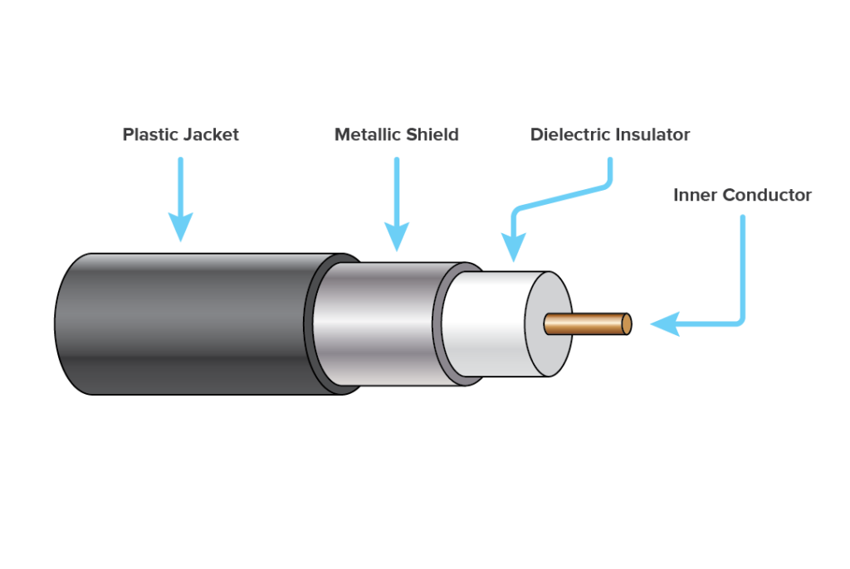

* **Unshielded Twisted Pair (UTP):** 
  + A cable with pairs of wires twisted together to reduce interference. Lacks additional shielding

**Used in**:  
LAN (Ethernet), telephone lines, modern networking.

**Example**:

* Cat5 – up to 100 Mbps
* Cat5e – up to 1 Gbps
* Cat6 – up to 10 Gbps over short distances
* Cat6a/Cat7 – better shielding and higher speeds

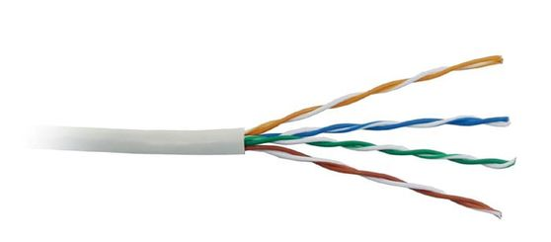

* **Shieled Twisted Pair (STP):** 
  + A cable Similar to UTP but includes foil or braided shielding to reduce electromagnetic interference.

**Used in**:  
High-interference areas like factories or hospitals

**Benefit**:  
Provides better noise immunity than UTP.

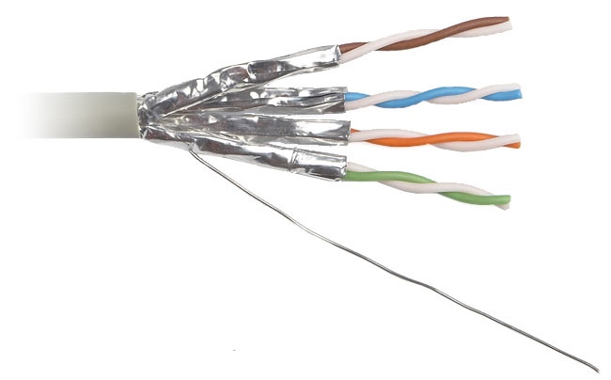

* **Fiber Optic Cable:** 
  + A **Fiber Optic Cable** is a type of network cable that transmits data using **light signals** through **glass or plastic fibers**, instead of electrical signals over copper wires.

**Key Features:**

* **High Speed**: Supports very high data transfer rates (up to Tbps).
* **Long Distance**: Can transmit signals over **kilometers** without signal loss.
* **Immune to Electromagnetic Interference (EMI)**: Ideal for environments with high interference.
* **Thin and Lightweight**: Fibers are thinner and more flexible than copper cables.

**Applications:**

* Internet backbone and broadband networks
* High-speed LAN connections
* Cable TV transmission
* Medical imaging and military communications

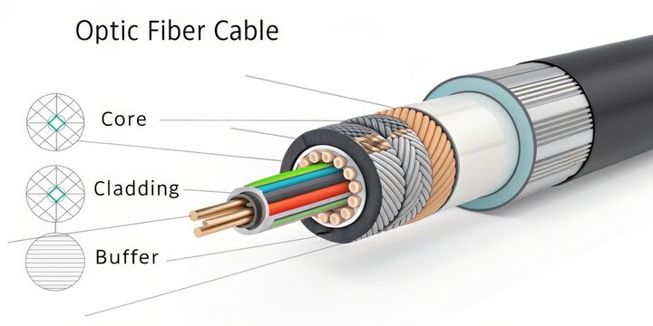

1. **Difference between guided and unguided media.**

|  |  |
| --- | --- |
| Guided Media | Unguided Media |
| Uses physical cables (like wires) | Uses wireless signals (no cables) |
| Example: Twisted pair, fiber optic | Example: Radio waves, microwaves |
| Signal travels through a medium | Signal travels through air |
| More secure and less interference | More prone to interference |

## Give cross-wired cable and straight through cable diagram (Color Code wise).

1. Cross-wired Cable Diagram (Color Code)

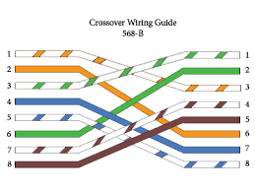

1. Straight Through Cable Diagram (Color Code)

